# Housing Project

1. Read the Input and Output data from housing.csv
2. Read the Median Income values into a variable X_bonus
3. Perform Imputation to fill any blank values in the input data
4. Perform Label Encoding on Ocean_Proximity Column to convert to numerical classification

Format

1. Split data into Test and Train
2. Standardize the data using Standard Scaler
3. Applied Linear Regression, Decision Tree and Random Forest models on the Train data
4. Applied predictions over Test Input data on each of the models
5. Calculated RMSE for each of the model predictions:
6. RMSE (Linear Regression) - 69826.89013012727
7. RMSE (Decision Tree) - 67116.265343338
8. RMSE (Random Forest) - 48819.290854349296
9. Calculated Scores for each of the models:
10. LR - 0.62607644048200073
11. DT - 0.65454379858990419
12. RF - 0.81722349789163073
13. Split the Bonus Input Data i.e Median Income Values into test and Train
14. Applied Linear Regression Model on Bonus Input Train Data
15. Performed Predictions over Bonus Input Test Data
16. RMSE for Bonus question = 84941.05152406936
17. Score for Bonus Question = 0.44668468048959442
18. Plot on Train Data for Bonus Question:

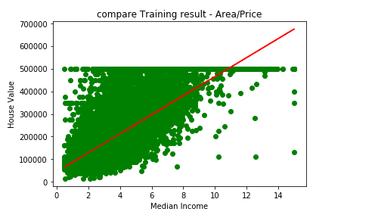

1. Plot on Test Data for Bonus Question

